**An Approach of Bridge Detection over Water in**

**High Resolution SAR images**

**Introduction**

SAR is an important means of remote sensing and SAR images are widelv used in many fields. Bridge is a very important military target, detecting bridges in a SAR image is very important. Bridge over water is a typical and important strategy target. It is of great significance not only for civilian but for military application to automatically detect bridge over water in SAR image. With the development of SAR imaging technology, the resolution of SAR image becomes higher, and the area of the bridge becomes larger. The bridges over water in high resolution SAR image are not line segments. Due to the difference of sampling and angle of view, the size, positionand direction of bridges are all different . The traditional parallel line extraction methods such as Hough transform and Radon transform do not consider the position relationship between bridge and river.

**Abstract**

Firstly, high resoultion SAR images are converted to grayscale images. Then, simple binary thresholding has been used to segment the water regions from the land regions using a suitable thresholding parameter. Secondly, noise reduction methods have been used to remove undesired blob regions. Then, a combination of morphological filters and logical operations were employed to distinctly obtain just the boundaries/contours of the water regions. Distinct loops of water region boundary points were pushed to different arrays and then Bridge Regions of Interest (ROIs) were detected. Finally, these Bridge ROI points were line fitted to detect the orientation and location of all bridge points.

**Pre-treatment/Pre-processing**

Conversion of SAR image to grayscale image using cvtColor(img,cv2.COLOR_BGR2GRAY) function. Now, we set a suitable threshold to convert the grayscale image to a binary image, water regions being black and land regions being white.

Then noise reduction was done using a denoising function of the opencv library.

**Segmentation and Edge Detection**

Based on the knowledge of relationship among the water, land and bridge, the bridge detection methods in high resolution SAR images generally include three steps: water segment, region of interest extracted and bridge detection. The main step is to segment the SAR images as water and land with the grey difference. Then morphological filters are utilized to segment water region and make the separate water regions connected. The difference regions between the segmented water regions before being connected and the ones connected are obtained as bridge ROIs to detect bridges.

Now, our interest is to find the borders of the water regions in terms of different contours or connected components.

We apply a composition of Gaussian blur, Median blur on the denoised image and furthur, thresholding with a suitable threshold to to get a smooth binary image of the original grayscale SAR image. Applying a second gaussian filter on this smooth image and applying the logical operation of subtracting the blurred image from this smooth image, we successfully obtain the silhouette of the land-water borders.

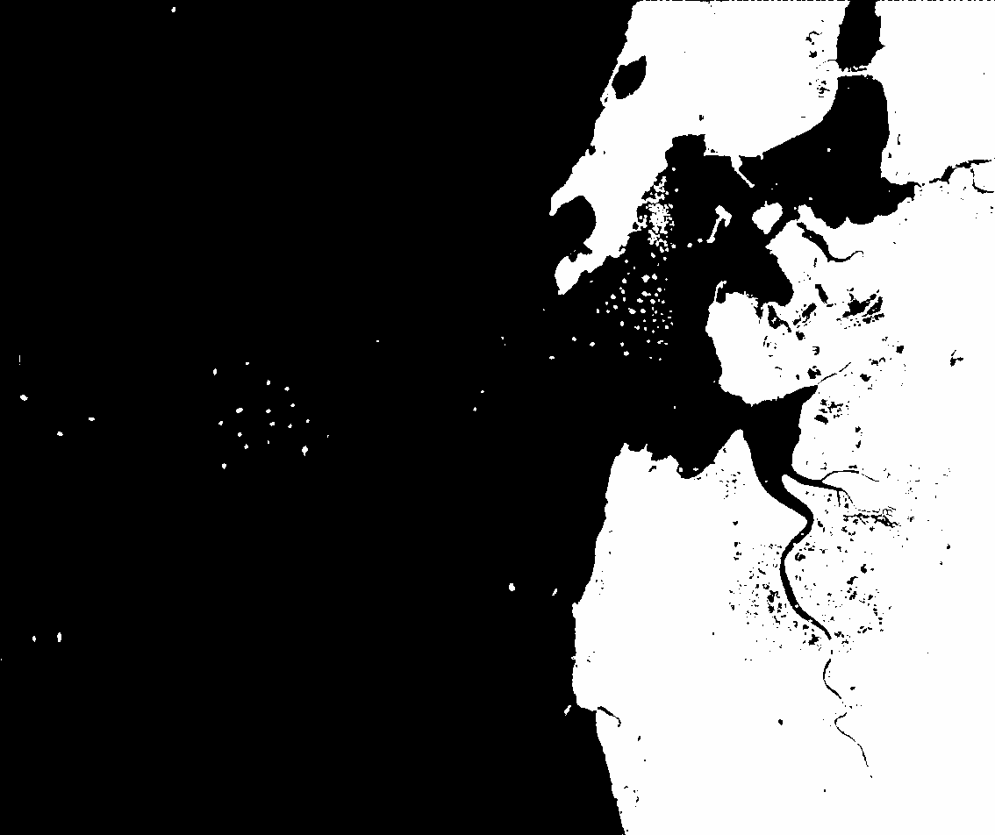 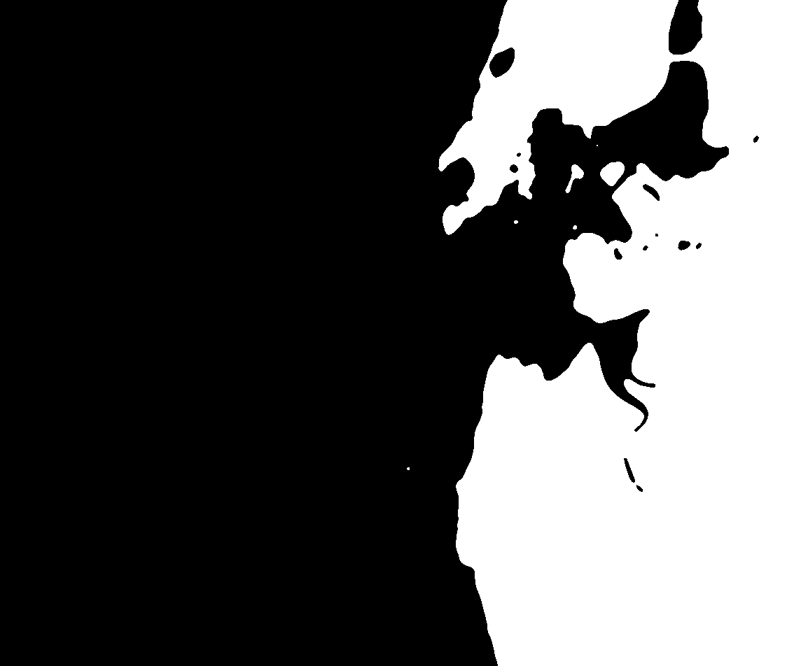

(a) Denoised SAR image of Mumbai (b)Thresholded binary image after

gaussian and median blurring

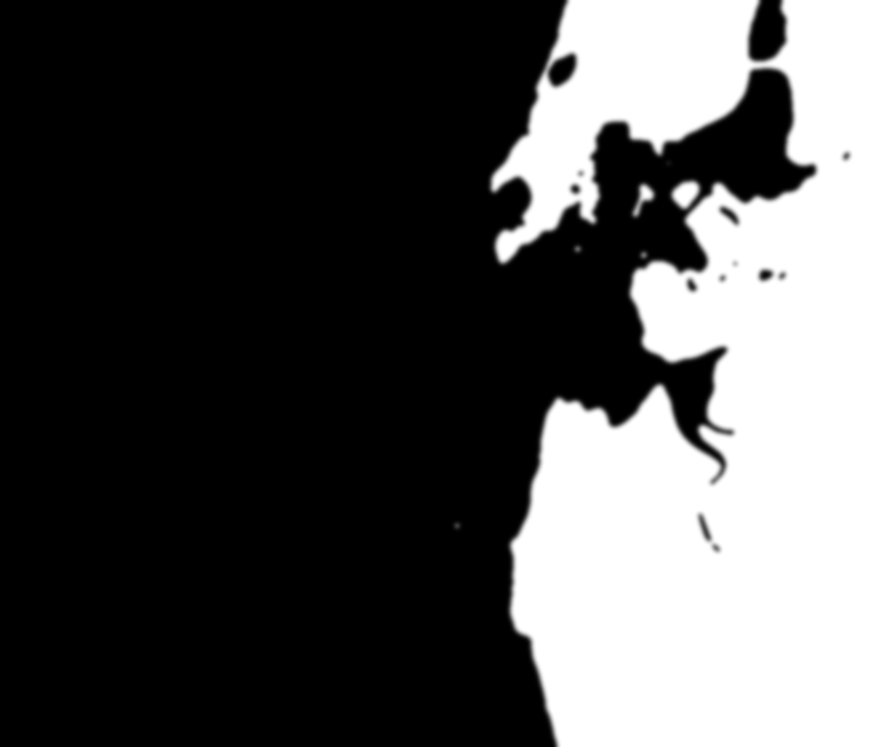 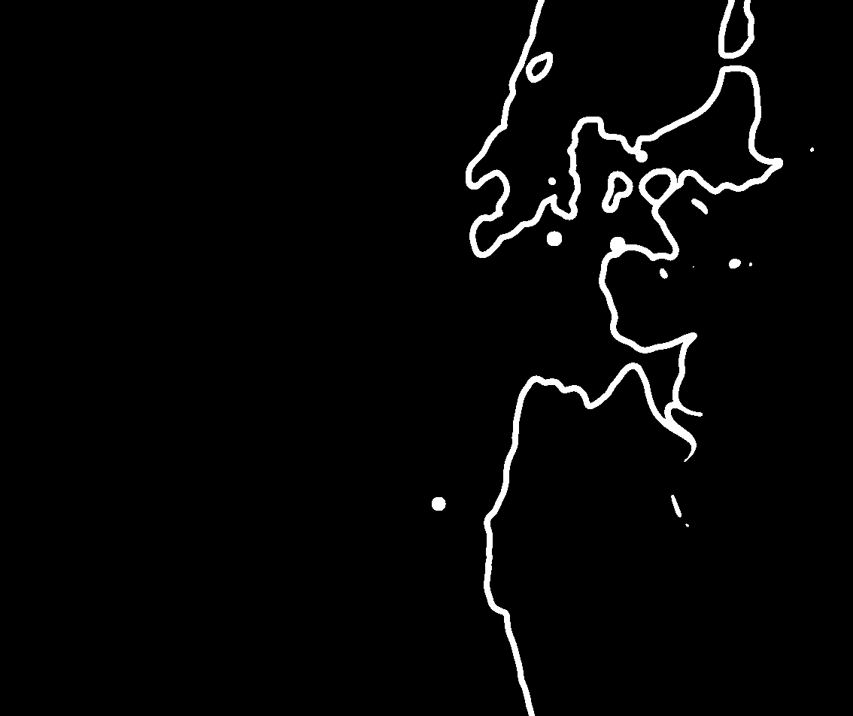

(c) Gaussian blur on (b) (d) = (b) - (c) Required border contours

Now, we convert the image (d) to a binary image using a suitable thresholding so that we get borders with limited thickness (helps in distinctly separating the different contours).

Next we identify these borders uniquely as it is crucial to detect the Bridge ROIs. We need to distinctly identify the borders of different water regions so that their points can be separately treated as part of different contours. Thus, we use the connectedComponents function of the opencv library to convert this grayscale border image to a labeled border image such that each connected label (continuous contour) has a different RGB value.

 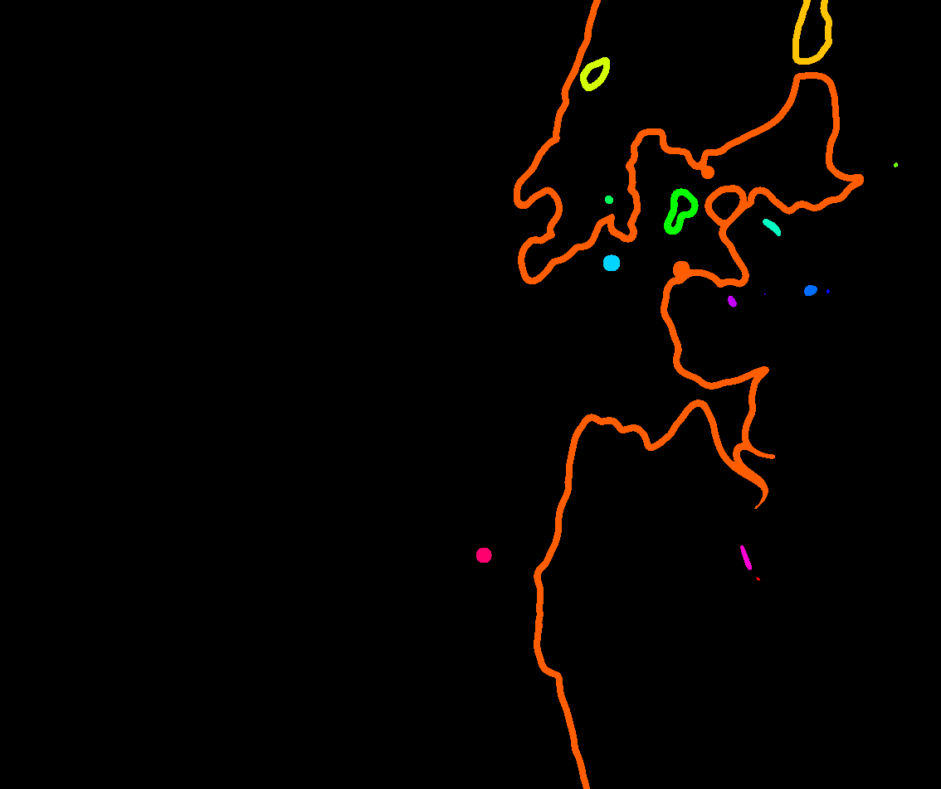

Binary image of (d) (e) Labelled image of different water bodies

We also remove the false labels by using a perimeter threshold and remove the unwanted labelled contours.

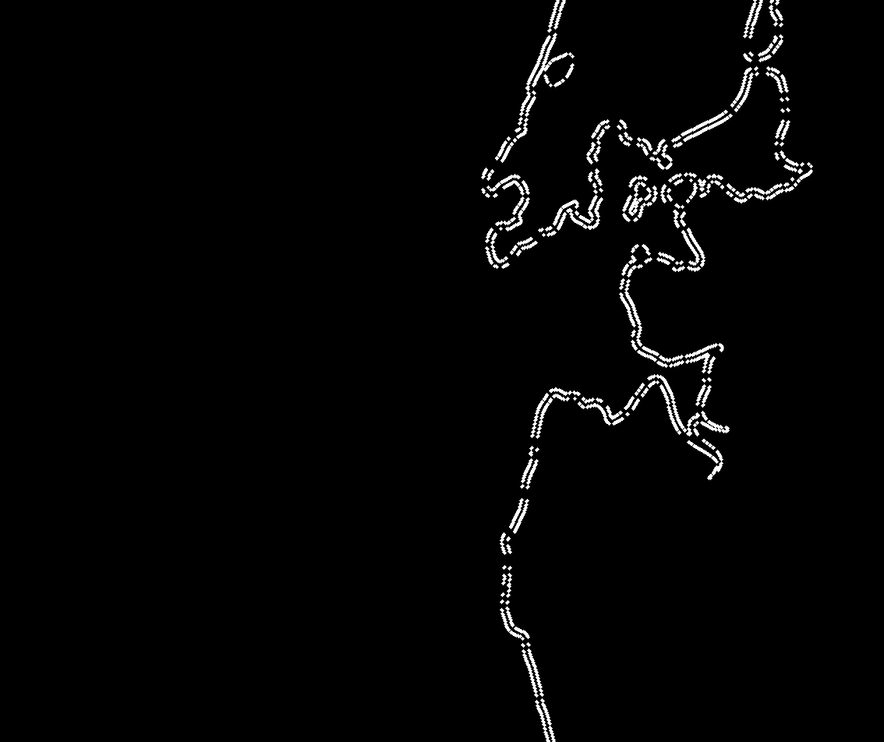

Then an algorithm for finding the closest pair of points between two different contours is used to detect Bridge ROIs. Only those closest pair of points are accepted as Bridge ROIs which are within a certain **width threshold**.

